  - A race to save your mission from certain doom.
CONTENTS:
- 15 Six-Sided Die (D6)
- 1 Six-Sided Die, #0-2 (2D6)
- 1 “Med-Bay” Tile
- 24 Hallway Tiles
- 5 Health Trackers
- 5 Health Markers
- 6 Parasite Pawns
- 5 Player Pawns
- 2 – 5 Players (Not included)
Cards:
- 9 “Role” cards
- 20 Room cards
- 48 Item cards
- 3 Parasite cards

Affliction
Gameplay:
Overview:
Gameplay is divided into turns which rotate clockwise starting from whoever is to the left of the Mad Scientist; During which players are able to (in any order):
- Play a card
- Move 1 space in any direction as long as there is a hallway, if not then you can place one hallway tile, and move into that hallway tile.
- Use their Roles ability
Detailed steps for Gameplay are provided on the next page.

Getting Started:
1: Deal Role Cards and Health Trackers
To begin setup, search the Role cards for the Mad Scientist Role card, set it aside, and shuffle the remaining 8 Role cards. Remove Role cards from the shuffled stack until you have a stack of an equal number of Players and Role cards, counting the Mad Scientist card. (For example, a 4-player game would have 1 Mad Scientist card and 3 other Role cards). Add the Mad Scientist card back into your new stack, before shuffling the stack and dealing 1 Role card to each Player, ensuring the Mad Scientist card is dealt out. Each player should then announce which role they have, before receiving one Health Tracker and one Health Marker. All Players begin the game at 3 health. Players are encouraged to adopt their roles stereotypical personality while playing the game.
2: Place Med-Bay tile and choose Pawns
Locate the “Med-Bay” tile and place it in the middle of your playing space. This will be the central room of the ship, and all players start there. Players then choose a Pawn and place it in the Med-Bay. At this time, the Room Cards deck should be shuffled and set in an area of the play space reachable by all.
3: Deal Item Cards
Search the Item card deck and set the parasite cards aside. Shuffle the remaining Item cards into one stack, and deal 7, face down, to each Player. Once the cards have been dealt, add the parasite cards back into the deck, and shuffle again. Players can look at their cards after they have been dealt.
A Troubled Voyage…
During a voyage carrying critical medical supplies to a distant Star-Base, you and your crewmates are suddenly attacked by an Unknown species of toxic Parasite who spread a highly noxious Infection, released into the ship by a devious stowaway, the Mad Scientist.
Your Mission:
To cleanse the ship of all 3 Parasites before the Mad Scientist has all Non-Infected players in the Med-Bay at the same time.

Important Terms:
“Adjacent”- any hallway or room tile that is directly connected to the player/parasites current room or hallway. This means that only the hallways or rooms that are 1 “space” away from your current position. (ie: in a very long hallway of multiple hallway tiles with a parasite room at the bottom, only the one hallway connected to the room is infected)



Gameplay
Turn Breakdown:
1: Starting out
Gameplay begins to the player on the left of the Mad Scientist and rotates clockwise around until play reaches the Mad Scientist again, after which the round ends and a new round begins.
1: Rounds
A round is started during the first turn of the game and concludes after the Mad Scientist finishes their turn in that initial round. A new round begins after play rotates to the next player after the Mad Scientist. Infection damage is calculated for all players after a round ends.
2: Action Phase
During the Action Phase, players must do any of these 3 things, in any order, but only once per turn. Players are NOT allowed to pass turns.
1: Move
Players can move into any Hallway or room adjacent to their current space. Players can only move once per turn, unless their role specifies otherwise (ie: Captain), or they are in Possession of a Flashlight card (see Card Description for details)
a: No Hallways
During a players turn if they wish to move in a direction with no Hallway Tile, they may place one Hallway Tile of their choice in any valid space adjacent to their current position, before moving into that space, using their Movement for that turn.
2: Play an Item Card
Players can play any one card from their hand at any time during their turn.
a: Add Room card
Add Room cards must be played before movement, in a similar manner to how Hallway tiles can be placed; However, you are not required to move into the room. When this card is played, you must draw a card from the Room Card deck, and you must place the room in any valid adjacent space, identically to how you would place a Hallway tile. Room cards all have unique actions, which are executed whenever that room is entered, unless it is a parasite room, in which case a parasite pawn and corresponding infection die are applied immediately after placing the room.
3: Use Roles Ability
Every role has a unique mechanic called an Ability. These are powerful traits individual to each role that allow them to perform some kind of movement boost, healing of players, or other Ability detailed on their Role card. Abilities can only be used once per turn.
A: Mad Scientist: The Mad Scientist is the only role with two abilities, and both can be used in the same turn.
3: Draw a card to finish your turn
After you have finished Moving, playing your item card, and/or using your Roles Ability, you must draw a new card from the deck. Players can only have 7 cards in their hand at a time, so if an Item card was not used during your turn, you must discard a card from your hand before drawing a new one. Players must have 7 cards in their hand at all times.


Win Conditions:
Mad Scientist: All other players must be in the Med-Bay with at least one parasite remaining (either in the Room Deck or on the ship).
Crew Members: All parasites must be found removed from the ship.
Player Health:
Overview:
Every Player in the game, including the Mad Scientist, has a Health Tracker. The health tracker is numbered 0-3, with 0 meaning that you have no remaining health, and 3 meaning you are at full health. Throughout the game, players will be shot or infected, and must update their Health Tracker accordingly.
1: Getting sent to the Med Bay
When your Health is 0, you are immediately teleported to the Med Bay (regardless of your location on the ship) and your turn ends. While in the Med Bay, you are incapable of performing any regular turn actions. Every time you would have a turn, you automatically heal 1 health point. Once your Health is greater than 0, you can then freely perform any regular turn actions. Players in the Med-Bay can also be healed by the Medic, or by another player with a Med-Kit, as described on the appropriate card.
a: Mad Scientist
The Mad Scientist follows the exact same procedure, including the ability to be healed by Medics, or other players.
Infection:
Overview:
Infection is the main driving force of the game and is what determines who wins and who loses. It can be spread via two main methods: A Parasite, or the Mad Scientist using one of their abilities. Infection is indicated by a D6 being placed on a hallway or room with the number displayed on the top face of the die indicating the level of infection in that room. Any Infection Level can never be greater than 6.
When your turn ends, if you (excluding the Mad Scientist) are in a hallway or room with an infection level higher than 3, you move your health marker 2 spaces left from its current position (you take 2 damage). If you end your turn in a room or hallway with an infection level lower than 3, you move your health marker left from its current position by 1.
Clearing/Manually Spreading Infection:
Infection can be cleared from a hallway or room with a Chemical Spray card. The card description describes the detail of the clearing/spreading process. The die of the targeted room should be updated to reflect the resulting Infection level
Parasites:
Parasites are spawned when the Parasite Room Card is placed. When this room is placed, a Parasite pawn is placed in that room, the parasite room and all hallways or rooms adjacent to it are now infected with a level of 6.
1: Removing a parasite
Parasites can be removed from a room once the Parasites health equals 0. A Parasite has 3 Health Points which are indicated by the 3 pieces of the Parasite pawn. Any Player can use the Gun card to inflict damage to the parasite, following the rules laid out on the Gun card. Whenever damage is dealt to the parasite with the Gun card, remove pieces from the Parasite pawn equal to the amount of damage dealt.
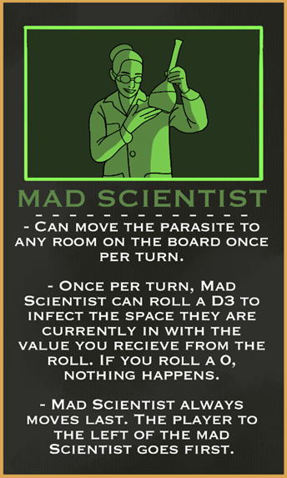
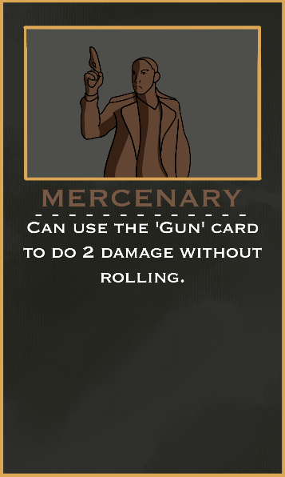
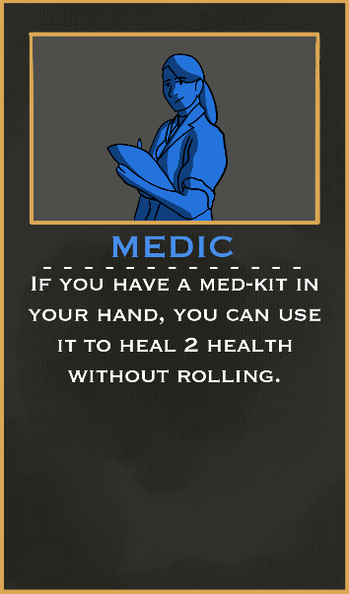
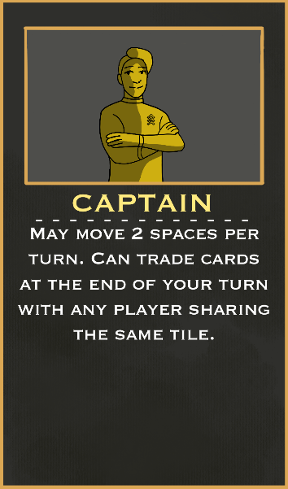
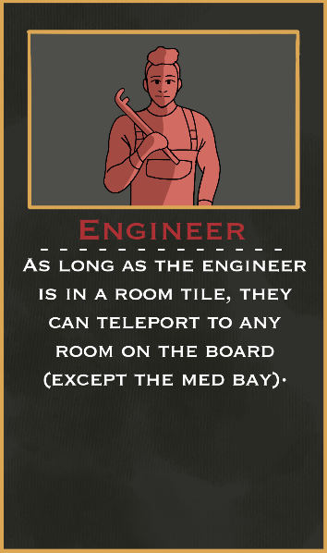
General Reference:
No player can deal any form of damage to any player that is in the Med-bay. The Med-Bay is equipped with state-of-the-art bullet deflection technology, meaning that any bullet that is destined to hit someone in the Med Bay will deal no damage. You ARE able to shoot THROUGH the Med Bay to hit somebody on the other side. If a player who is not the target is in the path of a Gun card, it deals no damage.
Can use both abilities in the same turn. If the Mad Scientist plays a Chemical Spray card, they can infect a space, instead of disinfecting. When a parasite is moved to any room (except the Med Bay), all adjacent rooms and hallways are infected in the same manner as if that room was a newly discovered Parasite room.
Cannot shoot if the Mercenary does not have a Gun card in their hand. If you do have a Gun card, you do not have to roll for effectiveness, but rather you will always deal 2 damage to your target. The Mercenary cannot shoot anybody who is currently in the Med Bay
Cannot heal if the medic does not have a med kit in their hand. The medic can heal any player in the game, including the Mad Scientist. If you do have a Med-Kit, you do not have to roll for effectiveness, but rather you will always heal 2 health from your target.
There is no limit on the number of cards you can trade. The captain is able to trade with the Mad Scientist, but is not required to do so. Trading can only take place after all other actions have been taken, but before the captain has drawn a card to end their turn. If the captain uses a flashlight, it will stack on top of the 2 spaces the captain can already move.
This ability includes rooms with Infection or a Parasite.

Role Reference

Credits

Created by: IUPUI Game Design Psychology Team “Shadow Wizard Team Name”, FALL 2023

(in no particular order)
Game Designers: Will Culpepper, Bellamie Moore, Ethan Surber, Sunny Mason
QA Testing: Will Culpepper, Bellamie Moore, Ethan Surber, Sunny Mason
Playtesting: Will Culpepper, Bellamie Moore, Ethan Surber, Sunny Mason
Rule Sheets: Ethan Surber, Will Culpepper
Art: Sunny Mason, Bellamie Moore
Chief Meeting Planner: Bellamie Moore
Dice Goblin: Sunny Mason
Bringer of Tape: Ethan Surber
The Courier: Will Culpepper
Hype Squad: Radar the Cat, Hawkeye the Cat, Monster Energy, Chick-Fil-A

Special Thanks: Professor Gary Maixner and Family for insights and encouragement

Affliction © 2023 by Ethan Surber, Will Culpepper, Sunny Mason, Bellamie Moore is licensed under CC BY-NC-ND 4.0. To view a copy of this license, visit http://creativecommons.org/licenses/by-nc-nd/4.0/

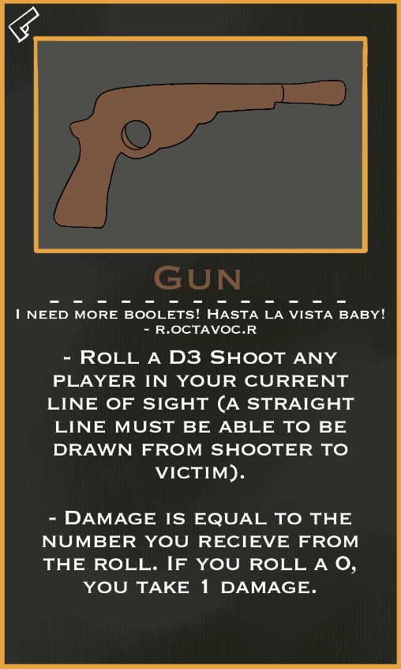
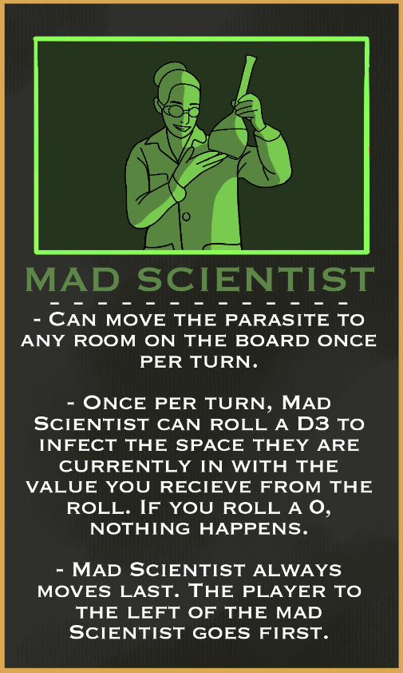
Role Card:
Role cards have multiple text blocks which describe the Roles Abilities. These abilities can be used once at any time during your turn, and vary depending on role. These Abilities are powerful tools that each player should utilize as often as they can throughout the game.
If you are the Mad Scientist, the border around your roles image will be green. If you are any other role, the border around the image will be gold.
Item Card:
Item cards have a small icon in the top left of the card indicating what the item card is. One item card can be played per turn. The item card description is the first block of text on the card, below the flavor text. Some cards have multiple text boxes describing additional details or specific use cases for certain roles.

Card Layout

